Collapse of the Kimono Wednesdays
Name
Institution
Professor
Course
Date

Table of Contents
Contextual Analysis 3
Analysis of the La Japonaise 3
Structure and Nature of the Painting 3
Significance of the Kimono Wednesdays and its Failure 3
Media Critique 4
Perspectives of the Protesters 4
Cultural transfer, Commoditization, and Appropriation. 4
The Decolonize our Museum Campaign 4
Perspective of the Japanese Consulate 5
Social Media Criticism 5
Critical Evaluation of the Media Critique 5
Postcolonial Theoretical Analysis 5
Orientalism 5
Cultural Appropriation 6
The Cultural Transfer Theory 7
References 8

Collapse of the Kimono Wednesdays

Contextual Analysis
Analysis of the La Japonaise
Claude Monet's 1876 portrayal of La Japonaise, lately exhibited at the Boston Museum of Fine Arts (BMFA) in 2015, exemplifies the French impressionist's fusion of European and Japanese cultural elements. The oil on canvas work measures 231.8cm by way of 142.3cm and depicts Monet's spouse, Camille Doncieux, modeling a blonde wig and dressed in a crimson uchikake kimono at the same time as status on a tatami mat with uchiwa fans behind her. As Boffetta (2015) notes, the immediate visual motifs - the uchikake, tatami, and uchiwa - constitute actual artifacts of Japanese lifestyle and custom. However, Doncieux's conspicuously Western wig undermines the portrayal's illustration of Japan; her herbal hair color turned into black in place of blonde. Consequently, while Monet does combine some elements of Japanese subculture into the work, his Orientalist illustration through the lens of European ideals dominates the painting. The inclusion of the blond wig displays the privileging of Occidental over Japanese identity. (Boffetta, 2015).
Structure and Nature of the Painting
The composition of portrays famous deliberate alternatives by using the artist to deliver that means. The primary figures stare at once at the viewer, commanding interest. Monet systematically positioned the primary subjects within the middle of the canvas, creating a symmetrical divide that focuses the eye (Alleyne, 2020). The vibrant red hue of the kimono and the formal pose of the model reference motifs of traditional Japanese dance, underscoring cultural identity. The lady figure's robe capabilities samurai iconography, juxtaposing the strict expression and sword with femininity. Notably, Monet centered the samurai brand on the kimono, making sure of excessive visibility and emphasis. The version appears to grasp an open fan, which integrates the French tricolor alongside its edge, blending European and Japanese aesthetics in a manner that displays the tensions of cultural change. Furthermore, in the background, Uchiwa lovers provide vignettes of Japanese visual tradition, whether through a girl posed in a kimono or pics of an iconic, crimson-topped crane and rugged landscapes (Alleyne, 2020).
The lovers replicate and enlarge the relevant tableaux, elucidating for the viewer the deeply Japanese symbology. Indeed, the very title "La Japonaise" indicates the artist's intent to personify an entire subculture. Monet enacts each realism and exoticization, juxtaposing blonde Western hair towards the kimono at the same time as upholding Japanese motifs just like the martial fan and Uchiwa designs. The aesthetic interplay speaks to the attraction and influence among civilizations.
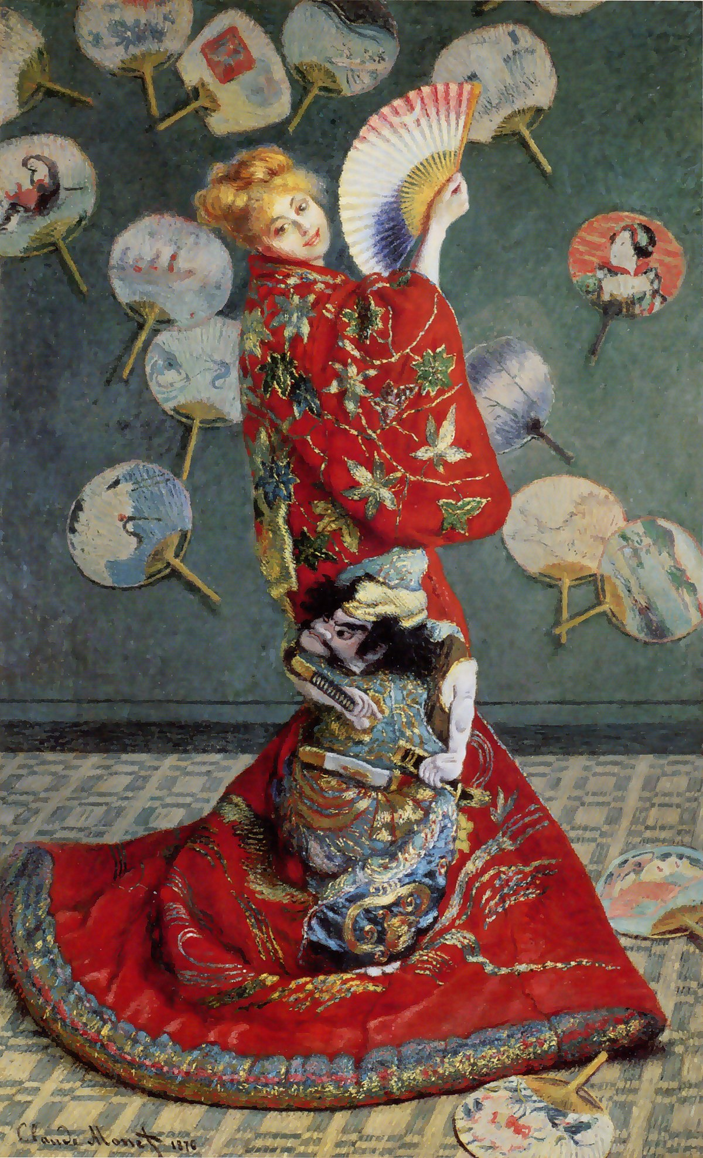

Significance of the Kimono Wednesdays and its Failure
As Duthille (2021) chronicles, the late nineteenth century marked the flourishing of “Japonisme” throughout Western artwork and culture, catalyzed through restored exchange routes to Japan. This fascination informed the Boston Museum of Fine Arts's attempted follow-up to a prior Japanese artwork show-off - the ill-fated "Kimono Wednesdays" spectacle proposing La Japonaise. However, the occasion quickly inspired backlash from the ones of Japanese background, considerably Japanese Americans, who condemned its commodification of tradition as Orientalist and appropriative. The museum first reacted by prohibiting kimono costuming however in the end had to bow to sustained protests and shut down the show off (Duthille 2021). Ironically, whilst Japanese officials had proven the setup, activists in America succeeded in suppressing the Orientalist overtones the show evoked for them. Their mobilization compelled the venerable cultural group to renowned worries approximately illustration.
Media Critique
The "Kimono Wednesdays" event ignited fierce debate across American society, in the long run sparking protests from the ones opposed on grounds of cultural appropriation as opposed to counter-protests defending the showcase. Asian-American activists argued that allowing traffic to don kimonos and mimic Monet's spouse Camille constituted Orientalist objectification, reducing Japanese history to extraordinary tropes (Alleyne, 2020). However, the Japanese consulate and some progressives contended the interactive installation meaningfully fostered an East-West cultural alternative. While the setup turned into designed to integrate Japanese and European motifs, activists deployed social media activism to press their reviews. Despite defenses that downplayed issues over essentialized representations, the sustained outcry, in the end, pressured the museum to cancel the occasion altogether. The outcome exhibits how marginalized corporations can assign mainstream establishments over problems of commodification and ownership of identity.
Perspectives of the Protesters
Critics of the showcase, especially in the Asian American network, argued that its invitation to get dressed in kimonos merely served to perpetuate Orientalist stereotypes and was suitable for an exoticized imaginative, and prescient Japanese identification (Boffetta, 2015). They contended that the museum was commodifying minority subculture to offer a pleasing spectacle for the intake of Western audiences. While the BMFA did initially restrict costuming, protesters endured in framing the occasion as an extension of the continued marginalization of Asian American views. By encouraging site visitors to mimetically objectify Monet's wife in her stylized Japanese garb, activists claimed the show-off amplified exoticism rather than go-cultural expertise. In their view, the setup reduced the elaborate cultural background to an ornamental curio reflecting Western needs rather than Japanese realities. Their steadfast pressure in the long run beat defenders' counterclaims approximately the artwork's political neutrality.
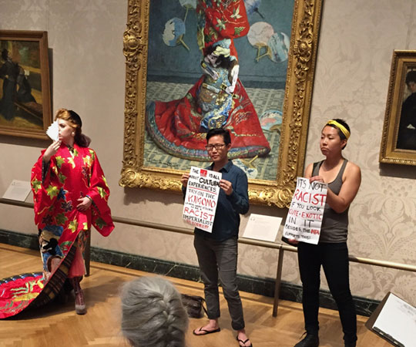
Cultural transfer, Commoditization, and Appropriation.
The exhibition of the Japanese way of life at the Museum of Fine Arts in Boston brought on debate about cultural switch, commoditization, and appropriation. Supporters considered the event as allowing a cultural switch – the system by which cultures exchange and share traditions and thoughts, as cultural transfer theory posits (Rodney, 2015). They argued that cultures inherently borrow from one another and aren't homogeneous or "pure." From this attitude, the "Kimono Wednesdays" occasion represented an organic example of pass-cultural trade. However, protesters criticized the events as cultural appropriation – the adoption of a minority organization's cultural factors by way of members of a dominant culture without suitable recognition for his or her beginning and significance. Specifically, they argued that the kimono symbolizes Japanese identity, so encouraging museum attendees to put on it dealt with this significant cultural artifact as a mere commodity. This fundamental disagreement illustrates the subjective nature of figuring out cultural appropriation. While museum organizers noticed the events as selling Japanese culture through go-cultural expertise, protesters considered equal sports as disrespectfully undermining the kimono's cultural importance in favor of business opportunism. In short, contrasting interpretations of cultural borrowing as either treasured exchange or insensitive appropriation were at the coronary heart of protests approximately the kimono occasions. This case underscores complex electricity dynamics implicit within intercultural interactions, especially whilst majoritarian cultures make use of minority corporations' cultural markers. More intercultural talk is probably required to set up together agreeable cultural change practices.
The Decolonize our Museum Campaign
Moreover, the "Decolonize our Museum" (DOM) campaign contended that the kimono represented no longer simply attire but a profound cultural product that became being inappropriately exploited for American functions, constituting cultural appropriation or even racism (Carriger, 2018). DOM proponents argued that the museum left out the garment's sociocultural importance for Japan, encompassing now not just apparel but additionally marking Japanese identification, feminine norms, social popularity, and indigenous values. Consequently, media outlets like the BBC, Forbes, and Washington Post accused the museum of cultural appropriation and difficult cultural switch, wherein the dominant Western lifestyle commandeered Japanese cultural traditions often for its gain (Alleyne, 2020). In sum, even as museum organizers noticed a possibility for a go-cultural connection, critics discovered strength imbalance and commoditization of valuable cultural symbols at the rate of the Japanese lifestyle. This case reveals the complicated dynamics of intercultural exchanges, frequently complicated beyond cultural domination, differing interpretations of cultural borrowing, and perceived threats to minority agencies' cultural self-determination when majority cultures make use of their traditional markers.
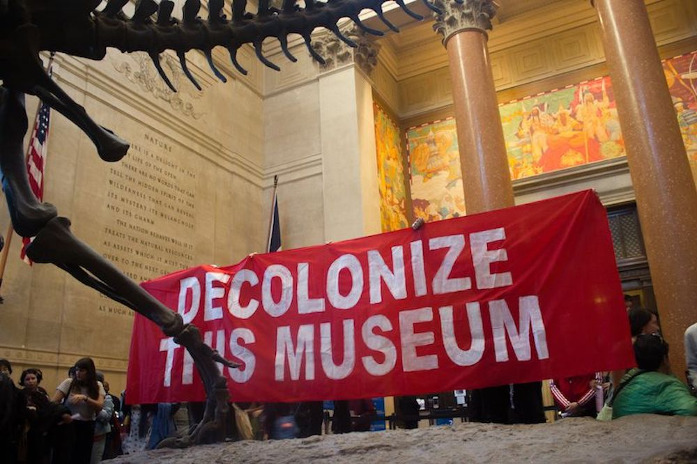
Perspective of the Japanese Consulate
However, perspectives on cultural appropriation remain complex. The Japanese consul noted its subjective nature, as checks depend in part on personal revel in the tradition in question and the sensitivity provoked (Rodney, 2015). Furthermore, many Museums of Fine Arts traffic criticized the kimono activities as perpetuating exoticized typecasting of Asian Americans that risked frightening studies of racism. Trying at the kimono resembled cultural cannibalism in the eyes of critics – thoughtlessly ingesting meaningful cultural artifacts from minority agencies, seizing preferred cultural remnants at the same time as brushing off their profound cultural importance. These comments underscored troubles posed by the museum's technique – even efforts to promote intercultural trade can exacerbate power imbalances that marginalize minority cultures. While the museum was supposed to foster cross-cultural connections by representing Japanese artwork, critics determined insidious cultural appropriation stemming from beyond-strength systems that commodified symbolic cultural apparel for American enjoyment. This case reinforces challenges in promoting variety while warding off cultural appropriation, and traumatic nuance beyond proper intentions to mitigate entrenched social inequities.
Social Media Criticism
The controversy precipitated substantial social media critique, which included a "Stand Against Yellow Face" Facebook page condemning the occasion as cultural appropriation. Protesters flooded the Museum of Fine Arts' Facebook with terrible feedback approximately the La Japonnaise exhibition, criticizing the failure to not forget the kimono's deeper cultural implications in want of exoticized leisure (Vezina, 2019). The museum's intentions had been possibly complicated through receiving a few preliminary aids from Japanese stakeholders, obscuring ability American objections. However, the protests discovered profound social justice problems posed by way of the museum's technique of cultural representation. Consequently, the museum canceled positive occasion additives, prohibited traffic from wearing kimonos, and issued apologies to folks who felt their culture was appropriated and distorted. Yet a few harms changed performed, as minority companies determined the commoditization of cultural artifacts using an outstanding cultural institution that overlooked broader social energy imbalances. This case has a look at reinforces the need for nuance and sessions with marginalized groups before which include their cultural markers in mainstream enjoyment or promotional sports. Cultural borrowing is multifaceted, stressful due diligence and deliberation to avoid similarly marginalization.
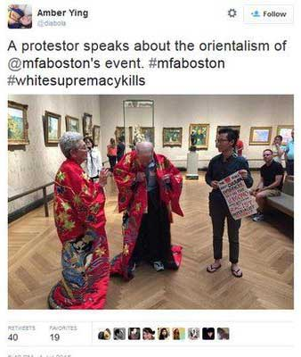
Critical Evaluation of the Media Critique
Fundamentally, the museum didn't understand the profound cultural significance of the kimono for Japanese human beings. Allowing traffic to put on this significant garment dealt with it as a costume or accent, exemplifying superficial cultural appropriation. The case shows intercultural complexities surrounding the accountable illustration of minority cultures. The cultural transfer concept distinguishes uploading aesthetic cultural markers from shifting underlying cultural understanding or respecting sensitivity around sacred artifacts (Rodney, 2015). Here, a majority of institutions extracted an exoticized cultural image for business functions without sizeable engagement with its culture which means, context, or implications. Effectively, even as the museum meant to have a good time in Japanese art, their method exemplified cultural imperialism – adopting minority cultural elements without context as leisure for the cultural majority. Asian American protesters discovered the commoditization of treasured cultural attire for publicity purposes with minimal information on its cultural implications. Consequently, even properly intentioned cultural sharing tasks demand deliberation to keep away from further marginalization (Alleyne, 2020). This case underscores asymmetrical strength dynamics that pervade intercultural exchanges, requiring nuanced consultation with marginalized groups to avoid inadvertent appropriation via floor-level switch. Cultural borrowing stays tricky, and dominant cultures must withstand grasping at exoticized artifacts without the considered necessary cultural reverence.
Postcolonial Theoretical Analysis
Orientalism
Theoretically, this example intersects with scholarly debates surrounding Orientalism and cultural imperialism. Orientalism refers to the conceptual framework coined utilizing Edward Said describing how Western cultures portray and exert strength over Eastern/Asian cultures via biased representations which can devalue and dominate minority corporations (Said, 2023). The kimono events arguably mirror such dynamics - the museum adopted a Japanese cultural image for Western amusement absent proper cultural context.
Specifically, while the museum noticed the kimono as simply a fancy dress, it contains strong cultural that means for the Japanese regarding female identity and conventional practices. Reducing it to a distinctive accent for Western traffic helps arguments that Orientalist biases persist through cultural appropriation, commoditization, and misrepresenting artifacts from less powerful cultural businesses (Said, 2023). Indeed, many Asian American protesters related their enjoyment of the occasion to broader emotions of marginalization, an awful lot as Said described minority agencies trapped by using cultural imperialism despite developing range.
However, analyzing this cultural interaction via an Orientalist attitude raises complexities. Historically, Japan represented an impressive colonial power in the nineteenth century in preference to a dominated lifestyle, and hard strict applications of Orientalism (Foucault, 2020). Moreover, whilst Monet himself depicted Japanese tradition through La Japonaise, Japan had a considerable global impact. Nonetheless, cutting-edge electricity dynamics surrounding minority way of life representation in America may have overshadowed this context, requiring deliberation around potential Orientalist biases.
Ultimately, at the same time as the protesters’ criticisms arguably aligned with Orientalist perspectives on Western cultural dominance, the museum possibly did not intend outright cultural imperialism. This case complicates applications of Orientalism, disturbing nuance. However, it nonetheless famous choppy intercultural strength dynamics in need of redress. Cultural institutions have to carefully replicate illustration ethics to eschew the imperialist commodification of minority cultures.
Cultural Appropriation
Fundamentally, the case represents cultural appropriation, defined as adopting cultural factors devoid of sensitivity to their unique importance, regularly tied to electricity imbalances among cultures. The museum acknowledged in apologies that showing artifacts absent participation with stakeholders to ensure cultural concerns prompted the protests (Takagi, 2021). Effectively, the majority of museum organizers prioritized an exoticized, American-centric revel in of Japanese way of life over input from Japanese minorities, reflecting the subjugation of marginalized views. Therein lies unequal cultural trade inappropriately ruled through Western interpretations – the essence of condemnation as cultural appropriation.
Additionally, cultural appropriation in fashion frequently distills significant cultural symbols into majoritarian entertainment without cultural context, thereby threatening traditions. While a few cultural diffusion resists easy designation as appropriation, adopting minority cultures' meaningful artifacts dangers commoditization that deprives them of inherent means (Young, 2010). Here, protestors feared normalizing wearing kimonos would detach the garment from its ritualistic significance denoting Japanese identity and background. If over-popularized abroad, the kimono should lose intangible means – exemplifying the risks of cultural appropriation.
This case exhibits complicated intercultural power dynamics and protestors' shielding posture protects meaningful cultural touchstones from appropriative threats. Cultural institutions ought to recollect collaborative illustration, now not unilaterally determining suitable parameters for displaying minority cultures' artifacts. Shared authority resists privileging majority interpretations, supporting mitigating risks of appropriative domination. Moving forward, the onus lies with museums to consciously curtail their historical penchant for cultural imperialism while engaging various communities.
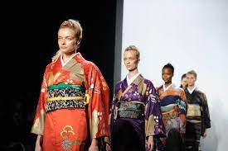
The Cultural Transfer Theory
The cultural transfer idea intersects this situation, whereby cultures combine by exporting and uploading traditions. Therein, dominant cultures can suitable minority practices absent right trade, as critics might argue the museum exemplified Western imperialism eating Japanese tradition devoid of consultation (Lee, 2021). Effectively, absent deliberation, cultural switch risks merely validating more potent societies commandeering weaker companies' artifacts for leisure, normalizing cultural appropriation.
However, proponents use the cultural transfer principle to justify cultural borrowing as an inevitable, benign byproduct of globalization (Duthille, 2021). This perspective would help the museum's integration of Japanese culture by promoting intercultural recognition via experiential learning, downplaying protests as obstructionist. Arguably, the museum intended to use Japanese culture respectfully, surprised by way of accusations of appropriation despite efforts at illustration.
Ultimately, at the same time as cultural switch theories can offer a range of intercultural knowledge of initiatives, this case reveals the need for nuance. Cultural alternate without collaboration dangers propagating current power imbalances. While the concept rightly notes that cultures evolve through change and integration, moral considerations need to mood majority powers adopting minority practices. The cultural switch should entail a collaborative method, no longer the unilateral imposition of dominant groups' entertainment choices devoid of stakeholder input. Here, although the museum meant pass-cultural engagement, failing to consult Japanese representatives undermined support, illustrating the risks of majority-imposed cultural integration.

References
Alleyne, A., 2020. What the Kimono's wide-reaching influence tells us about cultural appropriation. CNN.
Boffetta, E., 2015. Boston kimono exhibit in race row [WWW Document]. BBC News. URL https://www.bbc.com/news/blogs-trending-33450391 (accessed 1.3.24).
Carriger, M. L. (2018). No 'thing to wear': A brief history of Kimono and inappropriation from Japonisme to kimono protests. Theatre Research International, 43(2), 165-184.
Duthille, R. (2021). Cultural Transfer Theory and Exchanges between Britain and the Baltic in the Eighteenth Century. Medien der Aufklärung–Aufklärung der Medien. Die baltische Aufklärung im europäischen Kontext, 303-315.
Eicher, J. (1998). Dress and Ethnicity. Change across Space and Time.
Foucault, M. (2020). Power/knowledge. In The new social theory reader (pp. 73-79). Routledge.
Lee, S. (2019). Cultural appropriation in contemporary fashion. Archives of Design Research, 32(2), 137-151.
Rodney, S., 2015. The Confused Thinking Behind the Kimono Protests at the Boston Museum of Fine Arts. Hyperallergic.
Said, E. W. (2023). Orientalism. In Social theory re-wired (pp. 362-374). Routledge.
TAKAGI, M. (2021). The Kimono Protests: Race and Cultural Appropriation in Japonisme. Bowdoin Journal of Art.
Vézina, B. (2019). Curbing cultural appropriation in the fashion industry.

